**HAIR FOLLICLE DETECTION INITIAL RESULTS**

**TOOLS USED:-**

1. AWS
2. Python
3. OpenCV
4. C++
5. CVAT(For tagging and annotating)

**INITIAL PREPROCESSING**

The current batch of images were trained with simple algorithms from OpenCV for blob, contour and shape detection. The initial preprocessing steps applied to all the images were obtained from existing research papers that detail the use of image transformations for detecting hair.

However, due to the specificity of detecting follicles alone for this project, the transformers had to be modified to focus more intently at curved lines and follcile roots. The current preprocessing steps are as follows:-

1. Grayscaling and contrasting images
2. Image smoothing
3. Edge detection
4. Depixelization and denoising.
5. Deblurring for out of focus images.

The images above are some of the results from the preprocessing steps mentioned and illustrate the importance of using transformers to remove the background from the actual follicle regions. These transformers have been designed for static images currently and will be expanded on to moving gifs and videos to detect hair follicles.

**INITIAL METHODS TESTED**

The images above are some of the results from the preprocessing steps mentioned and illustrate the importance of using transformers to remove the background from the actual follicle regions. These transformers have been designed for static images currently and will be expanded on to moving gifs and videos to detect hair follicles.

The approach here was to move from a typical straight line detector to a curved line detector which can then be encoded to find the tips of root nodules with enough image tests. The results from these intial methods below show how the **Hough Transformer** has been modified to go from thick red determination vectors to more streamlined green contours. These contours are representative of the building blocks for the models that were later trained to work with corner and blob detection algorithms.

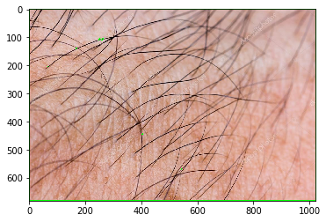

**CURRENT ALGORITHMS**

Corner and blob detection transformers perform a better operation for determining the root nodules from images but still require extensive training to be applied on all kinds of skin colors and hair colors. The images below show the results for root detection using various algorithms that were filtered after comparing accuracy metrics.

All transformers were presampled with a LoG(Laplacian of Gaussian) Transformer which proved to be most effective at determing roots(represented by the yellow spots in the first image). Extensive cleaning and preprocessing is still required to avoid mixing these points with ‘noisy background points’.

Further moving on from the LoG vectorization, corner and blob detection algorithms were thus used to pinpoint the follicle roots. The algorithms and their sample results have been ordered in terms of their best ability to match the metrics i.e., ratio of correctly identified roots to incorrect points in the image.

## Harris Corner Detection

**Shi-Tomasi Corner Detector**

## Scale-Invariant Feature Transform (SIFT)

**FAST Algorithm for Corner Detection**

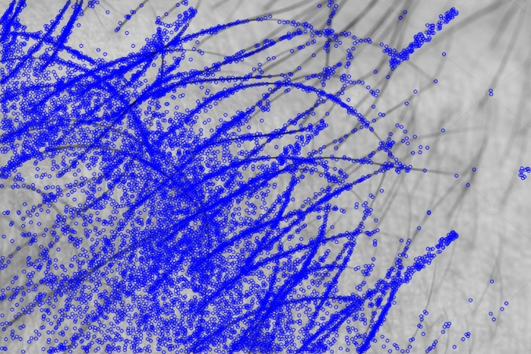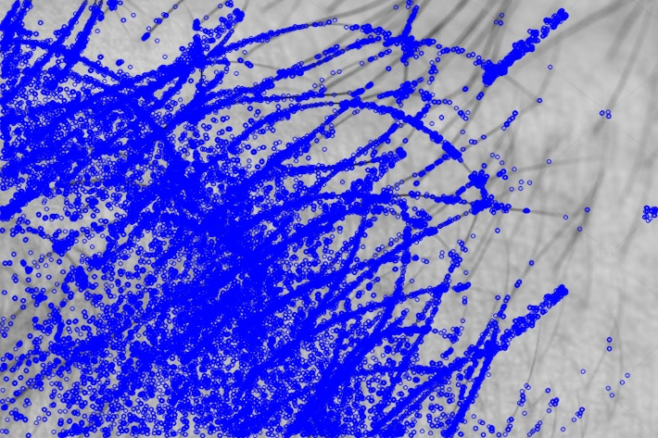

**ORB (Oriented FAST and Rotated BRIEF)**

**EDGE DETECTION STUDIES**

**Sobel Edge Detector**

**Laplacian Edge Detector**

**Canny Edge Detector**

**CONCLUSIONS AND FUTURE STEPS**

1. Apply LoG for all types of images moving ahead with new images with different skin and hair types.
2. Use Harris corner detection for pinpointing follicles.
3. Canny edge detector strangely performs the worst among all the tested algorithms, adding too much noise to the processed images. The decision to use either Sobel or Laplacian edge detector has to be validated with more images.
4. Future steps will now look into applying these models to moving type media(gifs, short videos) to confirm if they can be applied well.

References for Use:-

<https://www.researchgate.net/publication/338074507_Deep_Learning_based_Detection_of_Hair_Loss_Levels_from_Facial_Images>

<https://www.hindawi.com/journals/cmmm/2020/6908018/>

<http://www.ijicic.org/ijicic-140208.pdf>

<http://users.umiacs.umd.edu/~yaser/pamis.pdf>

<https://www.intechopen.com/books/computer-methods-and-programs-in-biomedical-signal-and-image-processing/an-efficient-block-based-algorithm-for-hair-removal-in-dermoscopic-images>

<https://www.researchgate.net/publication/323212461_Hair_detection_segmentation_and_hairstyle_classification_in_the_wild>

<https://www.hindawi.com/journals/tswj/2014/748634/>